|  |  |  |
| --- | --- | --- |
|  | GHAITSA : Islamic Education Journal Vol (4) Issue (2) 2023  <https://siducat.org/index.php/ghaitsa> | e-ISSN : 2721-1592: |

**ABSTRACT**

**BREAKING GENDER STEREOTYPES IN “BABY BLUES” MOVIE**

By : Iduwan, Merry Rullyanti, M.Pd, Lina Tri Astuty B. S, M.Pd

Email : iduwanbkl2019@gmail.com ,[merry.sasing@unived.ac.id](mailto:merry.sasing@unived.ac.id), sembiringlina07@unived.ac.id

Gender stereotyping is one of the undeniable facts of life. Gender stereotyping in movies is worth analyzing, since movies can have a significant impact towards the audiences. The objectives of this research were to find out the gender stereotypes of the main characters shown in “Baby Blues” Movie and to know the main characters break the gender stereotypes in Baby Blues movie. This study employed a qualitative descriptive method as research design aiming at collecting the data. Baby Bluesmovie was chosen as the object of this study. In this case, the researcher analyzed the breaking gender stereotypes of each character represented in this movie. The instrument used in this research was observation checklist and note taking. The note taking is developed by Evans and Davies (2009) theory. There were two findings of this research; (1) It is found that the gender stereotypes of the main characters such as Dika and Dinda consist of four aspect. Dika as a male has physical appearance (having a tall body, having muscular body, wearing shirt, t-shirt, and pant, having short hair, having mustache, strong body), Occupation as a waiter in a restaurant, personality traits (more dominant, emotionally stable, assertive), and Domestic Behavior (take care of finances and playing games). Moreover, Dinda as a female has physical appearance (having thin body, wearing dress, having long hair, beautiful and cute), Occupation as a housewife, personality traits (gentleness, warmth, being emotional, sensitivity), and Domestic Behavior (take care her children, clean the home, take care her husband); (2) On the otherhand, in the meantime, the main characters also break the gender stereotypes. Dika and Dinda break the gender stereotypes for personality traits and domestic behaviors. However, they still had similar physical appearance before the exchange happened. For personality traits, Dika was being gentleness, warmth, emotional, sensitivity, talk active, coward, and feminine. While Dinda was being more dominant, emotionally stable, assertive, lazy, rude, and manly. Moreover, for domestic behavior, Dika was being take care her children, clean the home, and take care her wife, while Dinda was being take care of finances and playing games.

**Key Words: Gender Stereotypes, Baby Blues Movie**

**INTRODUCTION**

**1.1 Background**

Movies have been part of many people’s lives. However, there is no clear definition of what a movie is. Even though Arnheim (1957) believes that movie is similar to literature, painting, music, in a way that it is used to produce artistic results, Kolker (2002) emphasizes that is hard to define movie since movies seem to have become a taken-for-granted part of most people’s lives. He points out that that movie is just movie; movie is just there to be enjoyed. Even though Kolker (2002) believes that movie can be considered as an art, since it is actually a text just like other art forms, he argues that movie is different in some ways. A text, according to Kolker (2002), is an understandable structure of meanings which consist of complex related events in a context. Moreover, Kolker (2002) added the differences between text in movies and in any other arts lie on their physical (photographic images), narrative (experience by watching the movie), economic and cultural (the production, distribution, and consumption) features. Furthermore, Wardaningsih (2017) states that the purposes of movie studies are to disclose and also explain the techniques which distinguish movie and any other literary works. In addition to this, Nelmes (2012) argues that movie studies is not only about the mechanics of movie making, but also how it affects the audience as well.

Movie can affect the audience through the social and cultural life presented. Like women juxtaposed with gentle nature, manners, emotional and also motherly. Meanwhile, men are juxtaposed with firm, strong rational and also mighty nature. Because gender is not a natural thing, the characteristics of the trait are interchangeable. That is, there are men who have gentle, emotional and motherly traits, while there are also women who have male traits such as strong, rational and mighty.

Gender stereotyping is one of the undeniable facts of life. Gender stereotyping in movies is worth analyzing, since movies can have a significant impact towards the audiences. Gender stereotypes shown in a movie can influence and shape the attitudes of those who watch the movie. For example, some children who watch Cinderella (1950) or Sleeping Beauty (1959) might be affected by the appearance of the princesses they see in the movies and start to imitate how they look, while some boys might want to be strong and heroic like the prince. Even though gender stereotypes can change over time, most movies portray their male and female characters in line with the traditional gender stereotypes. Traditionally, men are portrayed as someone who is strong, brave, adventurous and independent, while women are generally portrayed as powerless, dependent, and emotional.

Gender stereotypes are the beliefs that people have about the characteristics of males and females (Martin & Dinella, 2001). Gender stereotypes can hold back men and women in defining their identities. Furthermore, gender stereotypes make people culturally restricted in personality traits and behaviors, it can limit the life opportunities for both men and women in general. This may negatively affect an individual that they may get discrimination due to this stereotypes belief. Even though gender stereotypes generally inappropriate, society has accepted such belief and recognized it as a truth.

Despite, Butler’s theory of performativity give another perspective in defining gender binary. Butler (1999) defines gender as continuous process that performed repeatedly. Gender performativity give another insight in defining gender binary. Gender performativity is the opposite acts that break gender stereotypes. Individuals can present themselves as how they show the truly they are without following the rules of gender stereotype within the society. The biological sex is not following the real gender as society rules for every individual. Butler (1999) also argues that performativity is not only an action but a repetition of acts. Thus, the theory of gender performativity criticized gender binary opposition that limiting individuals’ identity.

There are some previous studies which analyzed about the gender stereotypes. First, a study by Ramdhan (2016) entitled “Gender stereotypes in Moana (2016): A movie analysis of the main character”. The analysis shows that Moana is portrayed as a character who possesses both masculine and feminine traits; the masculine traits, however, are more dominant that the feminine ones. This indicates that the movie tends to go against gender stereotyping by portraying a complexity of traits within the main character. Second, a study by Arjun et al (2022) entitled “Gender Stereotypes in Hollywood Movies and Their Evolution over Time: Insights from Network Analysis”. The results suggest that gender stereotypes are complex and dynamic in nature. Specifically, whereas male characters appear to be associated with a diversity of themes in movies, female characters seem predominantly associated with the theme of romance.

Third, Wulandari (2020) entitled “An Analysis Of Gender Stereotypes In Brave Movie”. The result of this research showed that there were four kinds of gender stereotypes found by the researcher in the movie. They were physical characteristics, occupations, domestic behavior and traits. From the dialogs in the movie, the researcher had found 17 data, 1 physical characteristic, 7 occupations, 7 personal traits and 2 domestic behaviors. Then, the next is the researcher had found 15 data of dialogues which were presented, that contained about the gender stereotypes. Thus, the Brave movie presented the gender stereotypes by the dialogues between the characters and the gender stereotypes focusing in feminist. In addition, the gender stereotypes were also proven in the country’s culture of this movie.

Fourth, a study by Nababan (2021) entitled “Breaking Gender Stereotype In Disney’s Mulan Movie Script”. The results of this study are the portrayal and characterization of each character in Disney’s Mulan movie. Mulan has black hair and a thin body figure. Her characters are brave, outspoken, independent and responsible, hardworking, and discipline. Meanwhile, Fa Li, the mother of Mulan, is plump with red cheeks, fair skin, and red lips. She indicates as a good woman and wife. Fifth, a study by Ji (2021) entitled “Analysis of Gender Stereotypes in Disney Female Characters”. According to the analysis result, gender stereotypes still exist both in Disney movies released before 2013 and that after 2013. Female characters have not escaped the shackles of male control, not only in appearance but also in action.

One of Indonesia movie which represents gender stereotypes is “Baby Blues”. Seeing this movie, the researcher is increasingly interested in exploring the differences between the male and female characteristic since the movie raises the issue of soul exchange. The soul of a husband with a male gender, with a relaxed personality, and a bit lazy is exchanged for his wife's soul with a female gender, a firm personality, and full of calculations. Therefore, the researcher will conduct a research entitled “Analysis of Gender Stereotypes of Characters in Movie “Baby Blues”.

**RESEARCH METHOD**

* 1. **Research Design**

This study employed a qualitative descriptive method as research design aiming at collecting the data in the field at the site where participants directly faced the phenomena of code mixing (Creswell, J.W & Creswell, J.D., 2018). Qualitative research involves collecting and analyzing non-numerical data (for example; text, video, or audio) to understand concepts, opinions, or experiences. It can be used to gather in-depth insights into a problem or generate new ideas for research.

* 1. **The Source of Data**

Baby Bluesmovie was chosen as the object of this study. In this case, the researcher analyzed the breaking gender stereotypes of each character represented in this movie.

* 1. **Research Instruments**

The instrument used in this research was observation checklist and note taking. The note taking is developed by Evans and Davies (2009) theory. Copenhaver’s (2002) and Evans and Davies’s (2009) frameworks above provide a concrete classification of feminine and masculine traits; Copenhaver (2002) provides more traits to classify and identify with, while Evans and Davies (2009) provide a concrete explanation of those traits. These lists by Copenhaver (2002) and Evans and Davies (2009) are only used as guidance as they believe that gender stereotypes traits are different for one person and the others.

* 1. **TheTechnique of Collecting Data**

The researcher collected the data of code-mixing by doing some steps of collecting data as follows :

1. Watching the movie.
2. Identifying the main characters of the movie
3. Noting all the gender stereotypes of each character
4. Classifying the gender stereotypes
   1. **Data Analysis**

In analyzing the data, the researcher did some steps;

1. Analyzing the gender stereotypes
2. Interpreting the findings
3. Concluding the findings

**FINDINGS AND DISCUSSION**

**4.1 Findings**

The synopsis of the movie Baby Blues tells the story of Dika (Vino G. Bastian) and Dinda (Aurelie Moeremans), a husband and wife who have just had a baby. However, instead of taking care of their children, the two of them quarreled more often. This happened because Dinda found it difficult to take care of the baby coupled with Dika who was indifferent and did not take care of her child. As a result, Dinda so experienced the baby blues syndrome. After a violent fight, the two become involved in a mysterious phenomenon that causes their souls to switch bodies. So, Dinda's soul is in Dika's body, and vice versa. This condition makes both of them exchange responsibilities and understand each other's conditions.

**4.1.1 The Gender Stereotypes of the Main Characters shown in “Baby Blues” Movie**

There are two main characters of Baby Blues movie; Dika as a husband and Dinda as a wife. Below are the gender stereotypes presented by Dika and Dinda in Baby Blues movie.

|  |  |  |  |  |
| --- | --- | --- | --- | --- |
| **Character** | **Gender Stereotypes** | | | |
| **Physical Appearence** | **Occupation** | **Personality Trait** | **Domestic Behaviors** |
| **DIKA** | Having a tall body | A waiter | More dominant | take care of finances |
|  | Having muscular body |  | Emotionally stable | Playing games |
|  | Wearing shirt, t-shirt, and pant |  | Assertive |  |
|  | Having short hair |  |  |  |
|  | Having mustache |  |  |  |
|  | Strong body |  |  |  |
| **DINDA** | Having thin body | A housewife | Gentleness | Take care her children |
|  | Wearing dress |  | Warmth | Clean the home |
|  | Having long hair |  | Being emotional | Take care her husband |
|  | Beautiful and cute |  | Sensitivity |  |

**Table 4.1 Gender Stereotypes of the Main Characters shown in “Baby Blues” Movie**

Table 4.1 showed that there were some differences of the gender stereotypes between Dika (husband) and Dinda (wife) before they exchanged each other. Dika as a male has physical appearance (having a tall body, having muscular body, wearing shirt, t-shirt, and pant, having short hair, having mustache, strong body), Occupation as a waiter in a restaurant, personality traits (more dominant, emotionally stable, assertive), and Domestic Behavior (take care of finances and playing games). Moreover, Dinda as a female has physical appearance (having thin body, wearing dress, having long hair, beautiful and cute), Occupation as a housewife, personality traits (gentleness, warmth, being emotional, sensitivity), and Domestic Behavior (take care her children, clean the home, take care her husband).

**4.1.2 The Breaking Gender Stereotypes of the Main Characters shown in “Baby Blues” Movie**

Here are the breaking gender stereotypes made by Dika and Dinda after they were exchange each other.

|  |  |  |  |  |
| --- | --- | --- | --- | --- |
| **Character** | **Gender Stereotypes** | | | |
| **Physical Appearence** | **Occupation** | **Personality Trait** | **Domestic Behaviors** |
| **DIKA** | Having a tall body | A waiter | Gentleness | Take care her children |
|  | Having muscular body |  | Warmth | Clean the home |
|  | Wearing shirt, t-shirt, and pants |  | Being emotional | Take care her wife |
|  | Having short hair |  | Sensitivity |  |
|  | Having mustache |  | Talk Active |  |
|  | Strong body |  | Coward |  |
|  |  |  | Feminine |  |
| **DINDA** | Having thin body | A housewife | More dominant | take care of finances |
|  | Wearing dress |  | Emotionally stable | Playing games |
|  | Having long hair |  | Assertive |  |
|  | Beautiful and cute |  | Lazy |  |
|  |  |  | Rude |  |
|  |  |  | Manly |  |

**Table 4.2 Breaking Gender Stereotypes of the Main Characters shown in “Baby Blues” Movie**

Table 4.1 showed that Dika and Dinda break the gender stereotypes for personality traits and domestic behaviors. However, they still had similar physical appearance before the exchange happened. For personality traits, Dika was being gentleness, warmth, emotional, sensitivity, talk active, coward, and feminine. While Dinda was being more dominant, emotionally stable, assertive, lazy, rude, and manly. Moreover, for domestic behavior, Dika was being take care her children, clean the home, and take care her wife, while Dinda was being take care of finances and playing games.

**1). Physical Appearance**

Physical appearance means the outward appearance of any person, irrespective of sex, with regard to hairstyle, beards, manner of dress, weight, height, facial features, or other aspects of appearance.

Example I.

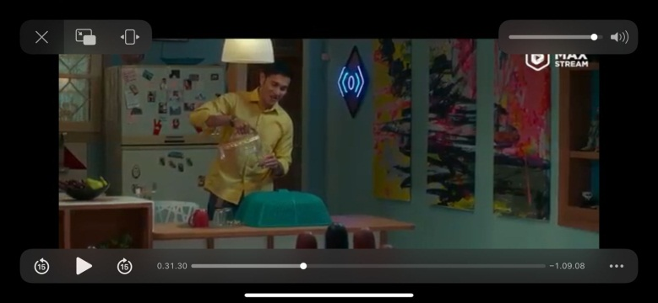

Picture 1

In picture 1 showed that Dika’ pyshical appearance was having a tall body, having muscular body, wearing shirt, t-shirt, and pant, having short hair, having mustache, and strong body.

Example II.

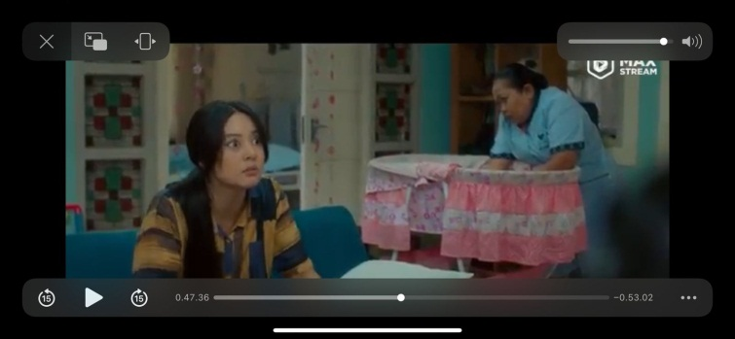

Picture 2

Dinda has pyshical appearance like having thin body, wearing dress, having long hair, beautiful and cute face.

**2) Occupation**

. Occupation means someone’s job or work. The occupation of Dika in this film is a waiter and Dinda is a housewife.

**3) Personality traits**

Personality traits are characteristics and qualities that help define you as a unique individual. They're often developed throughout life and may remain consistent across many situations and circumstances.

**a. Dika’ Personality Traits**

Dika’s personality traits in this movie breaking the gender stereotypes. He was being gentleness, warmth, emotional, sensitivity, talk active, coward, and feminine.

Example 1 (Talk Active)

In this movie, Dika’s character becomes more talk active and big mouth like a female as the example of two pictures above.

Dika: “*Lagian juga ada ibu aku yang bantu di rumah, orang tua kamu mana? Nengokin cucunya juga ngga. Malah sibuk jalan-jalan ke Bangkok”*

Adinda: “*Orang tua aku ngerayain 25 tahun pernikahan, paling tidak mereka tahu cara menikmati hidup, ngga nyiyir terus”*

(00:31:30)

Dika scolded Dinda and said that Dinda's mother was not there to help take care of her granddaughter.

Dika comes to shaman to get his body soul that is switched with Dinda. Dika becomes talk active because he scolded to the shaman in a harsh tone. It is rarely done by a man. Female usually more active to talk than man. That is why it is called breaking gender stereotypes. As Dika said:

Dika : “*langsung aja deh brur, ini ada solusinya atau ngga sih, udah keburu sore ntar angkotnya ngga ada”*

(00:59:31)

Example 2 (Sensitivity)

Dika becomes easy to cry. He is crying all the time when she was sad. As examples of some pictures below.

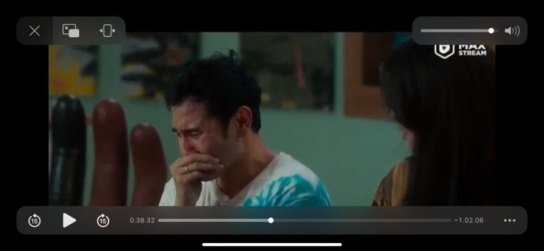

Picture 3

In picture 3, Dika was crying because he was affraid that he is being bullied by a Jinn. Dika said:

Dika: “*Jangan-jangan kita dipindahin setan lagi poy (sambil menangis)”*

Dinda: “*moy ah, mulutnya ih”*

Dika : “*Tapi beneran, aku yakin banget deh kita pasti dikerjain jin”*

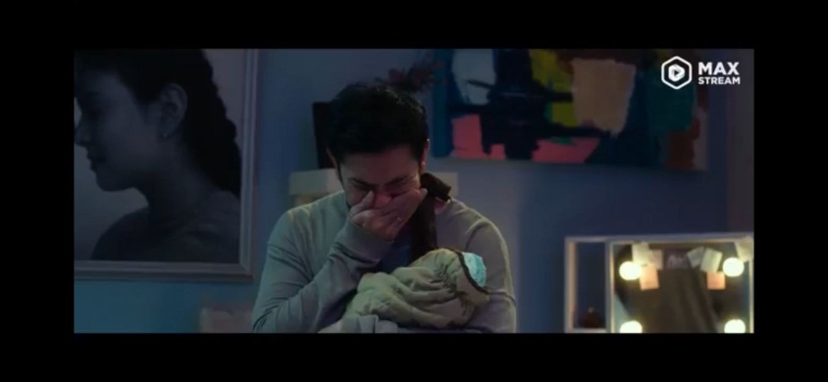

Picture 4

In picture 4, Dika was crying because Dinda’s mom and dad was breaking and getting divorce.

Example 3 (Coward)

In this film, Dika was also being coward and fear of anything. It was breaking gender stereotypes since a male must be strong but Dika is not.

Dika : “*kita pasti disantet deh”*

Dinda : “*poy ahh”*

Dika : “*aku ngerasa gremek-gremek gini aku takut poy”*

(00:37:43)

Dika was feeling affraid when his body switched with his wife.

Dika : “*aku takut poy, aku takut gak bisa balik lagi”*

Dinda *: “every mistake is gonna be alright”*

(00:51:56)

Example 4 (Feminine)

Dika character breaks the gender stereotypes because he becomes feminine. Some pictures below prove it.

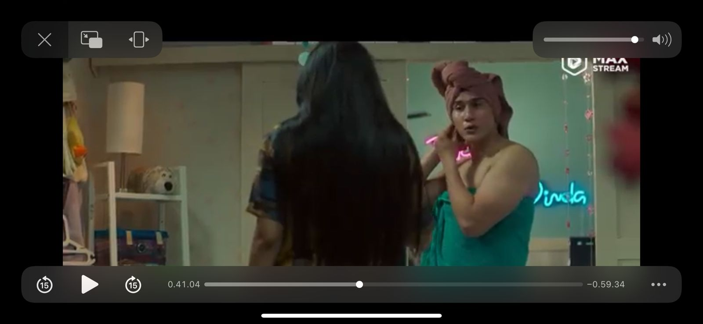

Picture 5

In picture 5, Dika wears a towel on his head like women in general. Dika angers to Dinda then said, “*yang kayak gini gini ni aku ga suka*”. Dika spoke gently like a woman in general.

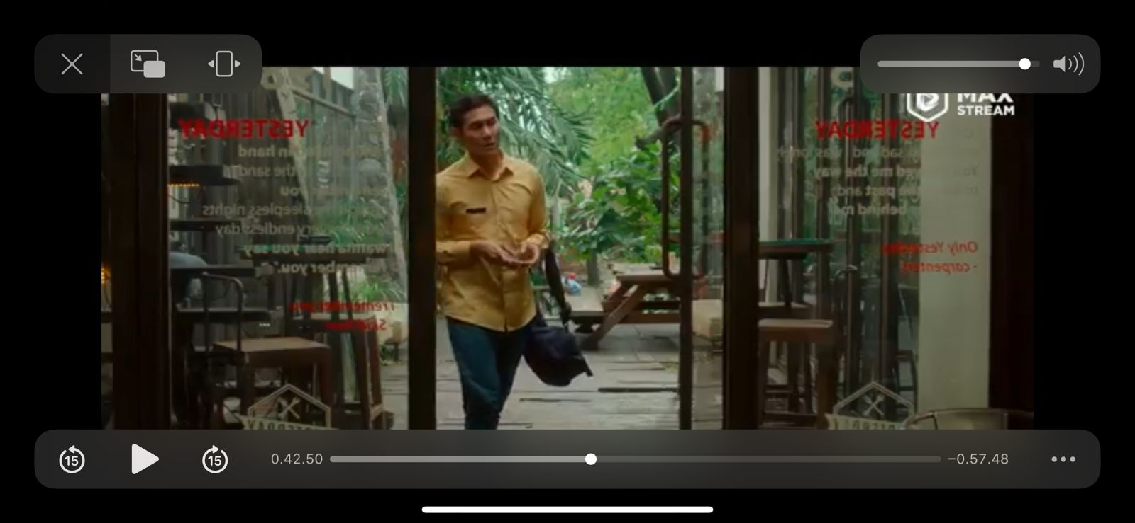

Picture 6

Picture above showed that Dika walks swaying and slowly when he goes to work. Dika brings pinky handphone in his work. Then his friend comes to him then said:

Sanusi : *“eh eh eh mana itu handphone tingki wingki pinki trilili trituti nya*”

Dika : “*oh ini punya istri gue, suka ngeheng jadi pulang kerja dia minta tolong bawain ke toko handphone”*

Sanusi : “*yaampun so sweet banget deh, percaya percaya”*

(00:43:05)

Dika holds and kisses her child

Mama Dika : “*Dara, kasian mama papanya”*

Dika : “*dari tadi ga mau tidur ni bu”*

Mama dika : “*udah sama nenek aja”*

(00:53:30)

Example 5 (Motherhood)

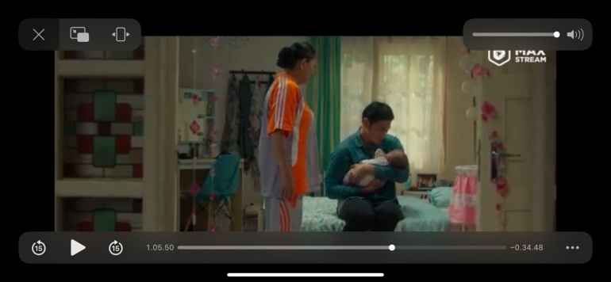

Picture 7

Dika carried Dara (her child) with great affection while asking Dinda to breastfeed Dara.

Dika: (*sambil menelpon dinda) kamu kalo mau megang dara tanggannya dibersihin dulu ya, kalo habis nyusuin harus dipikirin dong dipukpuk in. Apa lagi kalo dia habis makan.*

(00:43:45)

Dika :*memangnya Asi kamu kenapa: ga mau keluar lagi? Udah coba minum air yang banyak belum atau makan sayur katuk. Itu juga agak harus dipijit biar asi nya tu lancar.*

(1:04:19)

Dika : “*aku yang paling tau dara, selama ini aku yang urus dia. Kamu baru megang sebentar aja udah sok tau kayak gitu”.*

It can be concluded that there were five gender stereotypes of Dika showed as main character of Baby Blues Movie, namely; talk active, whining, coward, feminine, and motherhood.

**b. Dinda’s Personality Traits**

Dinda is a female, Dika’s wife who exchanged to male character. She has female body but her soul is a male. She was strong, cool, and also act like a man. In this movie, Dinda breaks the gender stereotypes since she was not act like a female or a mother.

Example 1 (Lazy)

Dinda is a lazy female. He always wakes up late and never try to make up her body, her face therefore her husband and her mother in law anger to her.

Dika wakes Dinda up and said:

Dika: “*Astaga Moy, bangun Moy, ini suami mau berangkat kerja bukannya disiapin apa kek, mandiin kek suami, suapin kek, malah tidur lagi kayak orang habis kerja rodi ah”.*

(00:08:22)

Moreover, her mother in law also tells her to keep her body clean and beautiful since she was so lazy after baby born.

Mama Dika : “*Heh, kamu sudah jadi ibu, tapi tetap jadi seorang istri, jaga dirimu. Masa suami pergi kerja yang dilijat istri yang kumel, nanti kalo diluar ketemu yang lebih wangi gimana? Paling ngga bedakan gitu loh”*

Adinda *: (terdiam sambil mencium aroma bajunya)*

(00:09:02)

Example II (Rude)

As a male soul who trapped in female body, Dinda becomes rigid and strong than Dika. Dinda often scolds Dika just because of small things and asks Dika not to be spoiled and afraid of whatever happens. Dinda does not take care of her child but plays PS. She instead asked a babysitter to take care of her baby.

Baby Sitter : *“terus, ibunya kemana?”*

Dinda : “*eh, saya sibuk bu banyak kerjaan”*

Example 3 (Manly)

Dinda is very good at playing ps even more than men. Dinda breaks the gender stereotypes that she can play a game which is identic to a male.

Teman Dika : “*wah ini ga bener ni, ini kenapa jadi pada gila semua ni”*

Dinda : “*anaknya Haji Roshid gimana?”*

Teman Dika : “*Dik, lu kenapa cerita-cerita sih? Ini kan rahasia kita berdua”*

Dinda : “*fik, se game lawan gue coba, ayook”*

(00:49:37)

To conclude, Dinda as another main character of Baby Blues movie has breaking the gender stereotypes. She is lazy, rigid, rude, and manly.

**4.2 Discussion**

There were two findings of this research; (1) Dika as a male has physical appearance (having a tall body, having muscular body, wearing shirt, t-shirt, and pant, having short hair, having mustache, strong body), Occupation as a waiter in a restaurant, personality traits (more dominant, emotionally stable, assertive), and Domestic Behavior (take care of finances and playing games). Moreover, Dinda as a female has physical appearance (having thin body, wearing dress, having long hair, beautiful and cute), Occupation as a housewife, personality traits (gentleness, warmth, being emotional, sensitivity), and Domestic Behavior (take care her children, clean the home, take care her husband). (2) Dika and Dinda break the gender stereotypes for personality traits and domestic behaviors. However, they still had similar physical appearance before the exchange happened. For personality traits, Dika was being gentleness, warmth, emotional, sensitivity, talk active, coward, and feminine. While Dinda was being more dominant, emotionally stable, assertive, lazy, rude, and manly. Moreover, for domestic behavior, Dika was being take care her children, clean the home, and take care her wife, while Dinda was being take care of finances and playing games.

The findings were in line with some theories related to gender stereotypes. Gender stereotypes are the beliefs that people have about the characteristics of males and females (Martin & Dinella, 2001). Gender stereotypes can hold back men and women in defining their identities. Furthermore, gender stereotypes make people culturally restricted in personality traits and behaviors, it can limit the life opportunities for both men and women in general. This may negatively affect an individual that they may get discrimination due to this stereotypes belief. Even though gender stereotypes generally inappropriate, society has accepted such belief and recognized it as a truth.

The differences on men and women communication may affect expectations for men and women in various fields of life. The different ways of men and women in communication can become a critical point of gender inequality. Because of those differences, men and women are treated differently. In terms of leadership, for example, women may be ignored for high position due to their emotional language. A study in the field of organization had shown that the capability of men and women to be a leader may be affected by the notions of emotional women’s language, which is not suitable for a leader (Mahmud, 2008b, 2009c). Brass (1985:327-343) also confirms that in many organizations, ‘differences in gender may be a surrogate for differences in job function, level in hierarchy, proximity, workgroup composition, numerical balance, and status’. Brass furthermore states that ‘women have not acquired status and influence compatible to that of their male counterparts in organizations.

Gender stereotype sets women should act feminine and not to do masculine action. In fact, being feminine is not always identical to women, and masculine is not always with a man. In female masculinity, Halberstam (1998:7) stated, “it is crucial that masculinity does not belong to men, and has not been produced by masculine women”. Based on the statement, we can see that masculine characters are not only possessed by men but also women. Masculinity and femininity are images that are constructed by society not based on identity. Denying the rights, opportunities, or resources of a certain gender are examples of this kind of discrimination. Differential treatment is then given to males and females based on stereotypic roles prevailing towards their gender, and that is the negative side of the wrongly taken gender stereotypes. Beforehand, gender stereotyping is more like discharging women especially, to be able to freely express because of the ‘bump’ created by society for female roles. The bump that is discussed here is some feminine stereotypes believed by many people and agreed by society.

**CONCLUSION**

Based on the findings**,** there are two conclusions that can be drawn related to the problems;

1. It is found that the gender stereotypes of the main characters such as Dika and Dinda consist of four aspect. Dika as a male has physical appearance (having a tall body, having muscular body, wearing shirt, t-shirt, and pant, having short hair, having mustache, strong body), Occupation as a waiter in a restaurant, personality traits (more dominant, emotionally stable, assertive), and Domestic Behavior (take care of finances and playing g ames). Moreover, Dinda as a female has physical appearance (having thin body, wearing dress, having long hair, beautiful and cute), Occupation as a housewife, personality traits (gentleness, warmth, being emotional, sensitivity), and Domestic Behavior (take care her children, clean the home, take care her husband)
2. On the otherhand, in the meantime, the main characters also break the gender stereotypes. Dika and Dinda break the gender stereotypes for personality traits and domestic behaviors. However, they still had similar physical appearance before the exchange happened. For personality traits, Dika was being gentleness, warmth, emotional, sensitivity, talk active, coward, and feminine. While Dinda was being more dominant, emotionally stable, assertive, lazy, rude, and manly. Moreover, for domestic behavior, Dika was being take care her children, clean the home, and take care her wife, while Dinda was being take care of finances and playing games.

**REFERENCES**

Arnheim, R. (1957). Movie as art. Berkeley: University of California Press.

Brannon, L. (2016). Gender: Psychological perspectives. Taylor & Francis. Retrieved from: http://www.ablongman.com/pa rtners_in_psych/PDFs/Brannon /Brannon_ch07.pdf

Boldry, J., Wood, W., & Kashy, D. A. (2002). Gender stereotypes and the evaluation of men and women in military training. Journal of Social Issues,57(4), 689-705.

Carli, L. L., Alawa, L., Lee, Y., Zhao, B., & Kim, E. (2016). Stereotypes about women, men, and scientists.

Copenhaver, B. B. (2002). A portrayal of gender and a description of gender roles in selected American modern and postmodern plays.(Unpublished master's thesis). East Tennessee State University. Retrieved from <http://dc.etsu.edu/etd/632>

Kimsey, C. M. (2011). Gender stereotypes bias in dystopian young adult literature (Unpublished master's thesis). University of North Carolina. Retrieved from https://cdr.lib.unc.edu/indexabl econtent/uuid:34a7dafa-1bb9- 48ad-8bb0-6d3571706522.

Kitch, C. (1999). Destructive women and little men: Masculinity, the new woman, and power in 1910s Popular Media. Retrieved from https://aejmcmagazine.arizona.e du/Journal/Spring1999/Kitch.pdf.

Kolker, R. P. (2000). Movie, form, and culture (3rd ed). Abingdon, Oxon: Routledge.

Kolker, R. P. (2002). Movie, form, and culture (4th ed). Abingdon, Oxon: Routledge.

Krahn, K. (2015). Reel women: gender stereotypes in movie (Doctoral dissertation). Eastern Michigan University, USA. Retrieved from: http://commons.emich.edu/cgi/ viewcontent.cgi?article=2015& context=theses

Mack, N., Woodsong, C., MacQueen, K. M., Guest, G., & Namey, E. (2005). Qualitative research methods: A data collector's field guide. Family Health International.

Mou, Y., & Peng, W. (2008). Gender and racial stereotypes in popular video games. Retrieved from https://msu.edu/~pengwei/Mou &Peng_gender and racial stereotype.pdf.

Murnen, S. K., Greenfield, C., Younger, A., & Boyd, H. (2016). Boys act and girls appear: A content analysis of gender stereotypes associated with characters in children’s popular culture. Sex roles, 74(1-2), 78-91. Retrieved from: [https://nature.berkeley.edu/gar belottoat/wpcontent/uploads/murnen-etal2106.pdf](https://nature.berkeley.edu/gar%20belottoat/wpcontent/uploads/murnen-etal2106.pdf)

Stoller, R. J. (1990). Sex and gender.

Karnac. Streiff, M., & Dundes, L. (2017). From shapeshifter to lava monster: Gender stereotypes in Disney’s Moana. Retrieved from https://www.mdpi.com/2076- 0760/6/3/91/pdf.

Streiff, M., & Dundes, L. (2017). Frozen in time: How Disney gender.